part 2

1. Find the output of the following program and explain the reason leading to the output

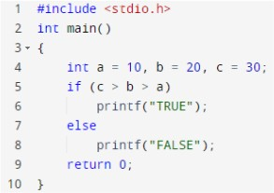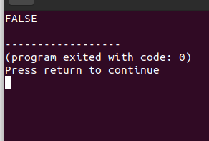

C>b>a

30>20>10 = (30>20)>10 = (True)>10 = 1>10= False

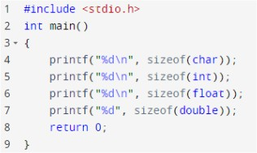

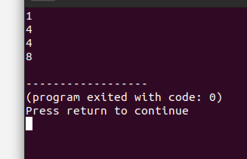

Byte size of char = 1, int and float =4 and double is 8

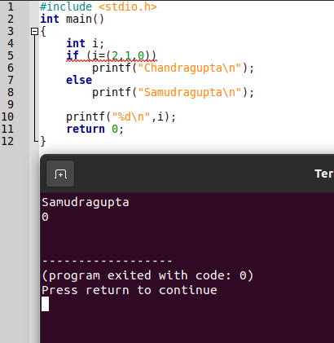

In (2,1,0) last value is 0 so false

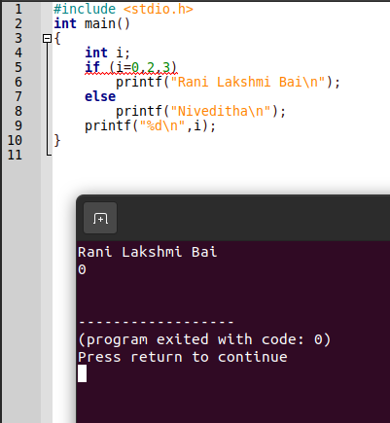

In 0,2,3 last value is 3 so true

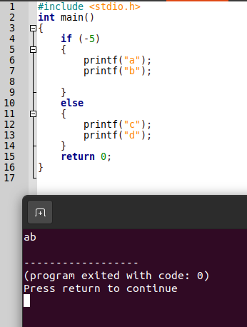

If statement is only false for 0 therefore true and if block is executed.

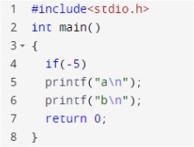

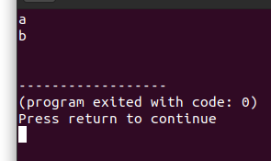

If statement is only false for 0 therefore true and if block is executed.

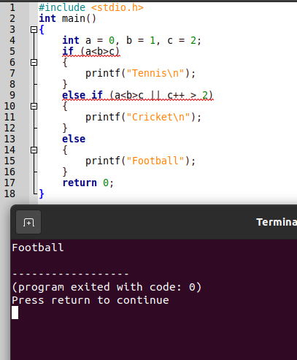

A<b>c=0<1>2=1>2=0 for if block is false

A<b>c || c++ >2 = 0<1>2 || c++>2 = 0 ||c++>2= 0 || 2>2 = 0||0=0 so else if is false. Therefore else block is executed.

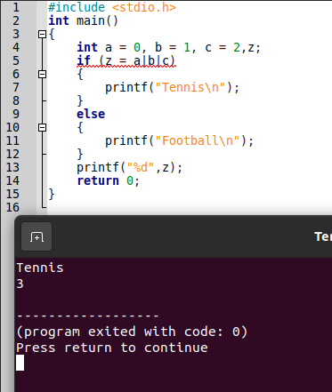

Z=a|b|c = 000|001|010 = 001|010 = 011 = 3

If 3 is true

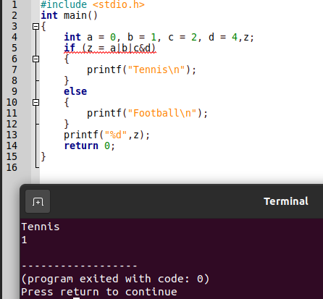

Z=a|b|c&d= 000|001|010&100 = 000|001|000 = 001 = 1

If 1 is true

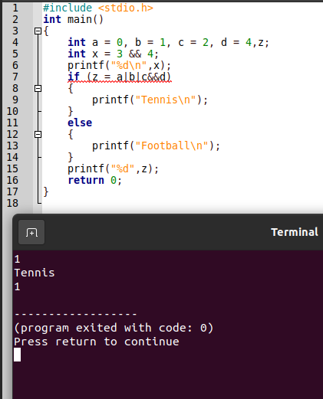

X=3&&4=1

Z=a|b|c&&d = 0|1|2&&4 = 000|001|010&&4 = 3&&4 = 1

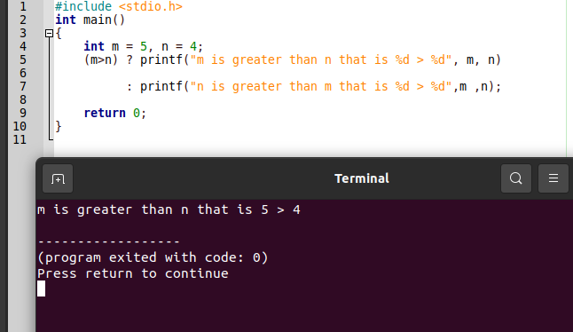

M>n = 5>4 = true therefore the first statement is executed

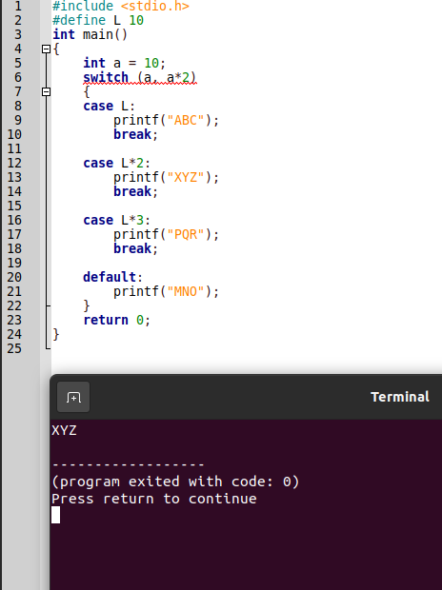

Switch (a,a\*2) = switch (a\*2) = 20 so case 20 = L\*2 is executed.

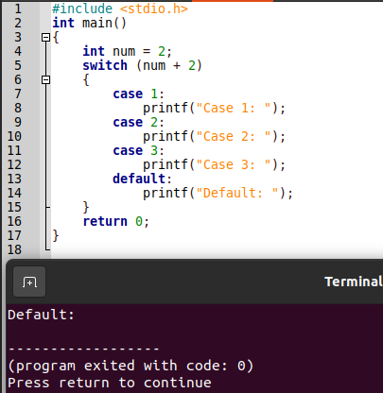

Num+2 =4 so case 4 is not there, so default is executed.

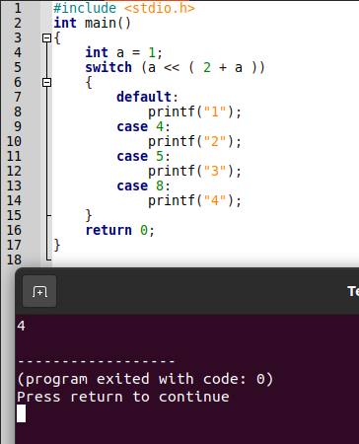

1<<2+a = 1<<3 = 0001<<3 = 1000 = 8

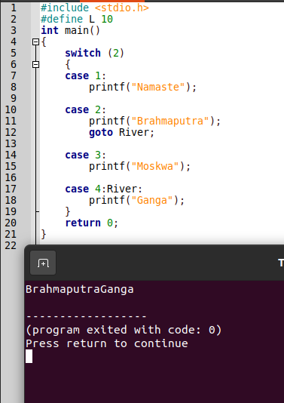

Case 2 is executed the the goto statement made so case 4 executed.

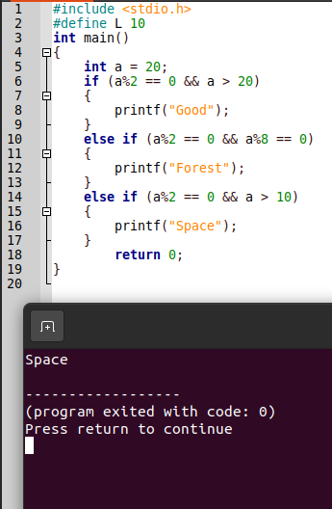

A%2==0 is true while a>20 and a%2==0 is false and a>10 therefore 3rd block is executed.